**Lead Scoring Case Study**

1. Which are the top three variables in your model which contribute most towards the probability of a lead getting converted?

**Ans.** These are the top variables that contribute towards the result

* Total Time Spent on Website
* Total Visits
* Lead Source with elements Google

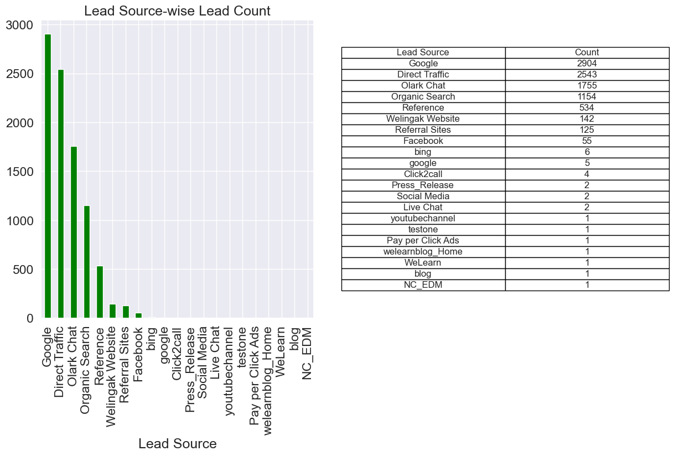

1. What are the top 3 categorical/dummy variables in the model which should be focused the most on in order to increase the probability of lead conversion?

Ans. Ans. Top 3 Categorical/Dummy variables to increase probability are:

* Lead Source with elements google
* Lead Source with elements direct traffic
* Lead Source with elements organic search

1. X Education has a period of 2 months every year during which they hire some interns. The sales team, in particular, has around 10 interns allotted to them. So during this phase, they wish to make the lead conversion more aggressive. So they want almost all of the potential leads (i.e. the customers who have been predicted as 1 by the model) to be converted and hence, want to make phone calls to as much of such people as possible. Suggest a good strategy they should employ at this stage.

Ans. Phone calls must be done to people if:

* They spend a lot of time in the website and this can be done by making the
* website interesting and thus bringing them back to the site.
* They are seen coming back to the website repeatedly
* Their last activity is through SMS or through Olark chat conversation
* They are working professionals

1. Similarly, at times, the company reaches its target for a quarter before the deadline. During this time, the company wants the sales team to focus on some new work as well. So during this time, the company’s aim is to not make phone calls unless it’s extremely necessary, i.e. they want to minimize the rate of useless phone calls. Suggest a strategy they should employ at this stage.

Ans.

* **Focus on High-Probability Leads:** Prioritize contacting leads predicted as '1' by the logistic regression model.
* **Segmentation Based on Probability:** Divide leads into categories (high, medium, low) based on conversion probability to allocate resources effectively.
* **Implement Lead Scoring:** Develop a scoring system integrating model predictions to prioritize follow-ups and engagements.
* **Automate Communication:** Use automated emails and targeted ads for lower priority leads to maintain engagement without direct phone calls.
* **Continuously monitor:** the effectiveness of these strategies through metrics like conversion rates and lead response times.